HYGIENE POLICY
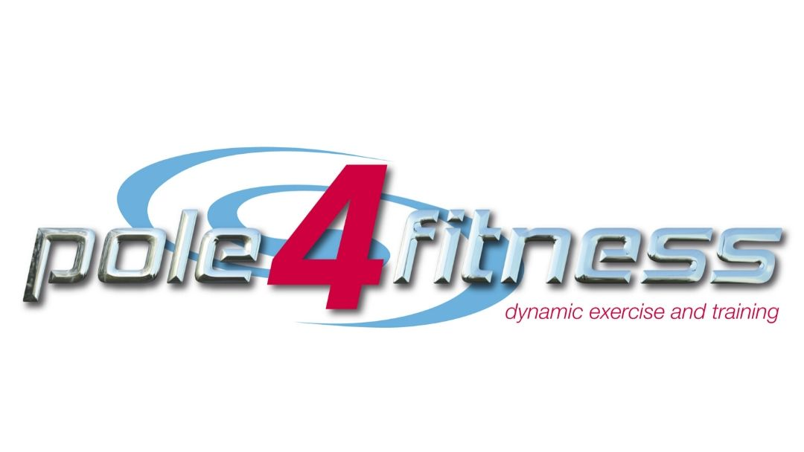
INSERT LOGO HERE
At Pole 4 Fitness we have implemented the below hygiene policy
to help stop the spread of Covid-19 at this point.

We would ask that all students, instructors and other visitors to the studio abide by the below policy at all times. Failure to do so may result in removal from the studio with any future attendance suspended without a refund.
PERSONAL HYGIENE | - Wash hands with soap and water often for at least 20 seconds. This should be done as a minimum on entering and leaving the studio, after going to the bathroom and after coughing or sneezing..  - Use hand sanitiser gel if soap and water are not available  - Cover your mouth and nose with a tissue or your arm when you cough and sneeze  - Put the used tissue in the bin immediately and wash your hands  - Wear a face covering in situations where it is not possible to continually socially distance  - Avoid touching your eyes, nose and mouth while at the studio  - Avoid any close personal contact (hugs etc…) and follow our social distancing policy  - Avoid touching any ‘high contact’ areas where possible such as door handles  - Only use hand towels provided in class and place in the wash basket after use, do not bring your own
EQUIPMENT | - Only use the equipment you have been assigned to for the class  - Avoid touching any other equipment unnecessarily  - Only use the cleaning products provided for your piece of equipment  - For ground-based classes please bring your own mat as requested  - Please ensure you have your own grip aid – studio grip will not be available during this time
COMMON AREAS | - Common areas including toilet facilities will be cleaned and disinfected thoroughly before, during and after class. This also extends to door handles, light switches and other high contact areas  - Please avoid using common areas where possible, wait outside or in your vehicle before class until your instructor calls you in  - Please follow the 1 way system through studios in and out of class
WASTE | - Please ensure all waste is disposed of safely in the bin  - Please wash your hands after disposing of waste
VENTILATION | - Fans will be on and doors/windows open for the duration of your class. Please do not touch these. Please let an instructor know if you would like them adjusted
STUDENT STORAGE | - Please leave all non-essential items in your car, or your home – only bring to the studio exactly what you need for your class  - Lockers will not be available – please leave all car keys etc…. with your shoes
RIGGING | - Please do not touch or adjust any rigging above your equipment or any paging points – all rigging will be at a fixed height to avoid unnecessary cleaning at this time
HYDRATION | - Please ensure you bring your own water bottle with you for class.

