COVID 19 – INFORMED CONSENT
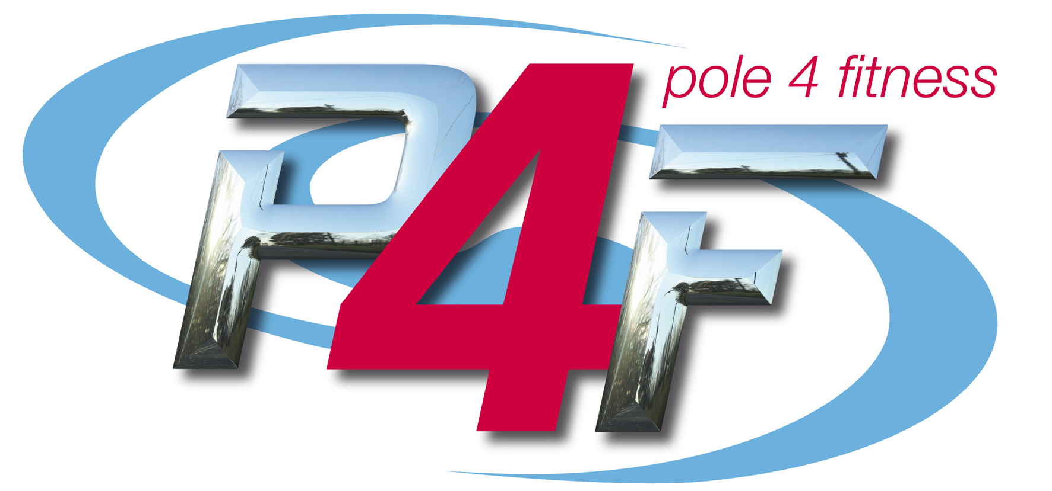

Please find below Pole 4 Fitness safety statement with regards to Covid-19. Please sign to say that each time you attend the studio, you agree to the following.
To the best of my knowledge, I:
Please Initial
Have not shown any symptoms of Covid-19 in the past 14 days. According to the NHS and Gov.UK, below are the main symptoms:
- High temperature
- New, continuous cough
- Loss or change to your sense of smell or taste
Have not been in contact with anyone who has tested positive for Covid-19 or shown any of the above symptoms in the past 14 days
Have worn a protective mask when in public situations where social distancing is not consistently possible
Understand I could be a carrier of Covid-19 and be asymptomatic
Understand that I could contract Covid-19 from an asymptomatic person at our studio or from a contaminated surface at our studio
Am fully aware of the studio’s safety procedures (posted on our studio wall) to prevent the spread of Covid-19 and will follow these procedures
Agree to inform the studio/school immediately if I have developed symptoms within a two week period of being in the studio, or if I have learned that I have been in direct contact with someone who has later tested positive for Covid-19 within the same two week period or travelled in the last 14 days to a Covid-19 risk area
Agree to inform the studio of any allergies that I may have to cleaning products, PPE or similar that may be used at this time and may adversely affect my health
Agree that my data provided on this form can be used to contact me if I have been in a class with a person that has developed symptoms or has been in direct contact with somebody who has later tested positive for Covid-19
Understand that if I wilfully and intentionally violate the stated hygiene policy and social distancing policy in our studio, the studio has the right to immediately remove me from class and suspend me from attending any future classes, without a refund
Agree to inform the studio immediately if I learn that any of the above information changes or I obtain new information

Name of Participant: ____________________________________________________________________________
Signature of Participant: _________________________________________________________________________
Signature of parent or Guardian if under 18 yrs _______________________________________________________
Date: _________________________________________________________________________________________
Contact details: ________________________________________________________________________________
Please find below Pole 4 Fitness safety statement with regards to Covid-19. Please sign to say that each time you attend the studio, you agree to the following.

To the best of my knowledge, I:

I have not shown any symptoms of Covid-19 in the past 14 days. According to the NHS and Gov.UK, below are the main symptoms:

High temperature
New, continuous cough
Loss or change to your sense of smell or taste

Have not been in contact with anyone who has tested positive for Covid-19 or shown any of the above symptoms in the past 14 days

Have worn a protective mask when in public situations where social distancing is not consistently possible

Understand I could be a carrier of Covid-19 and be asymptomatic

Understand that I could contract Covid-19 from an asymptomatic person at our studio or from a contaminated surface at our studio

Am fully aware of the studios safety procedures (posted on our studio wall) to prevent the spread of Covid-19 and will follow these procedures

Agree to inform the studio/school immediately if I have developed symptoms within a two week period of being in the studio, or if I have learned that I have been in direct contact with someone who has later tested positive for Covid-19 within the same two week period or travelled in the last 14 days to a Covid-19 risk area

Agree to inform the studio of any allergies that I may have to cleaning products, PPE or similar that may be used at this time and may adversely aﬀect my health

Agree that my data provided on this form can be used to contact me if I have been in a class with a person that has developed symptoms or has been in direct contact with somebody who has later tested positive for Covid-19

Understand that if I wilfully and intentionally violate the stated hygiene policy and social distancing policy in our studio, the studio has the right to immediately remove me from class and suspend me from attending any future classes, without a refund

Agree to inform the studio immediately if I learn that any of the above information changes or I obtain new information

