COVID-19 OUTBREAK PROCEDURE
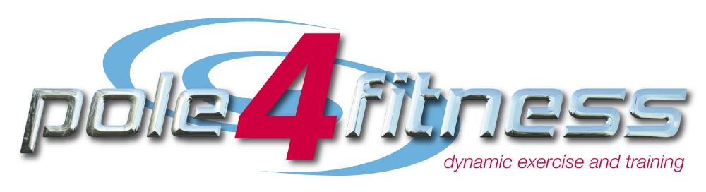
Pole 4 Fitness

STAGE 1 – NOTIFICATION
If you develop symptoms within a two-week period of being at the studio, or if you learn that you have been in direct contact with somebody who has later tested positive, we would ask you to contact Clare Bennett on 07766223155 or Pole4fitness@hotmail.com as soon as possible. Your name and personal details will be kept confidential at all times, as per our data protection policy.

STAGE 2 – TRACK AND TRACE
If somebody within your class has developed symptoms (or been in direct contact with somebody who has tested positive) and notified the studio, you will be notified as soon as possible and advised to isolate for 14 days. We will be using the contact details on your Covid informed consent to contact you so please ensure they are up to date.

STAGE 3 – CLEANING AND CLOSING
If we believe there have been cases of Covid-19 at the studio, then the studio will close for a period of 24 hours to allow our team to conduct a rigorous deep clean of the premises. All students will be notified of a closure as soon as possible using the contact details stated on your Covid informed consent. Any classes cancelled due to a studio closure will be refunded as stated in our T&C’s.

STAGE 4 – RECORDING
Any outbreaks will be recorded in full in the studio’s incident report book.

STAGE 5 – REOPENING
Once Stage 3 has been completed in full, the studio will reopen. All students will no notified by email with a confirmation of the reopening date and the up to date timetable.

